California Prunes
TEACHING MODULES ASSESSMENT

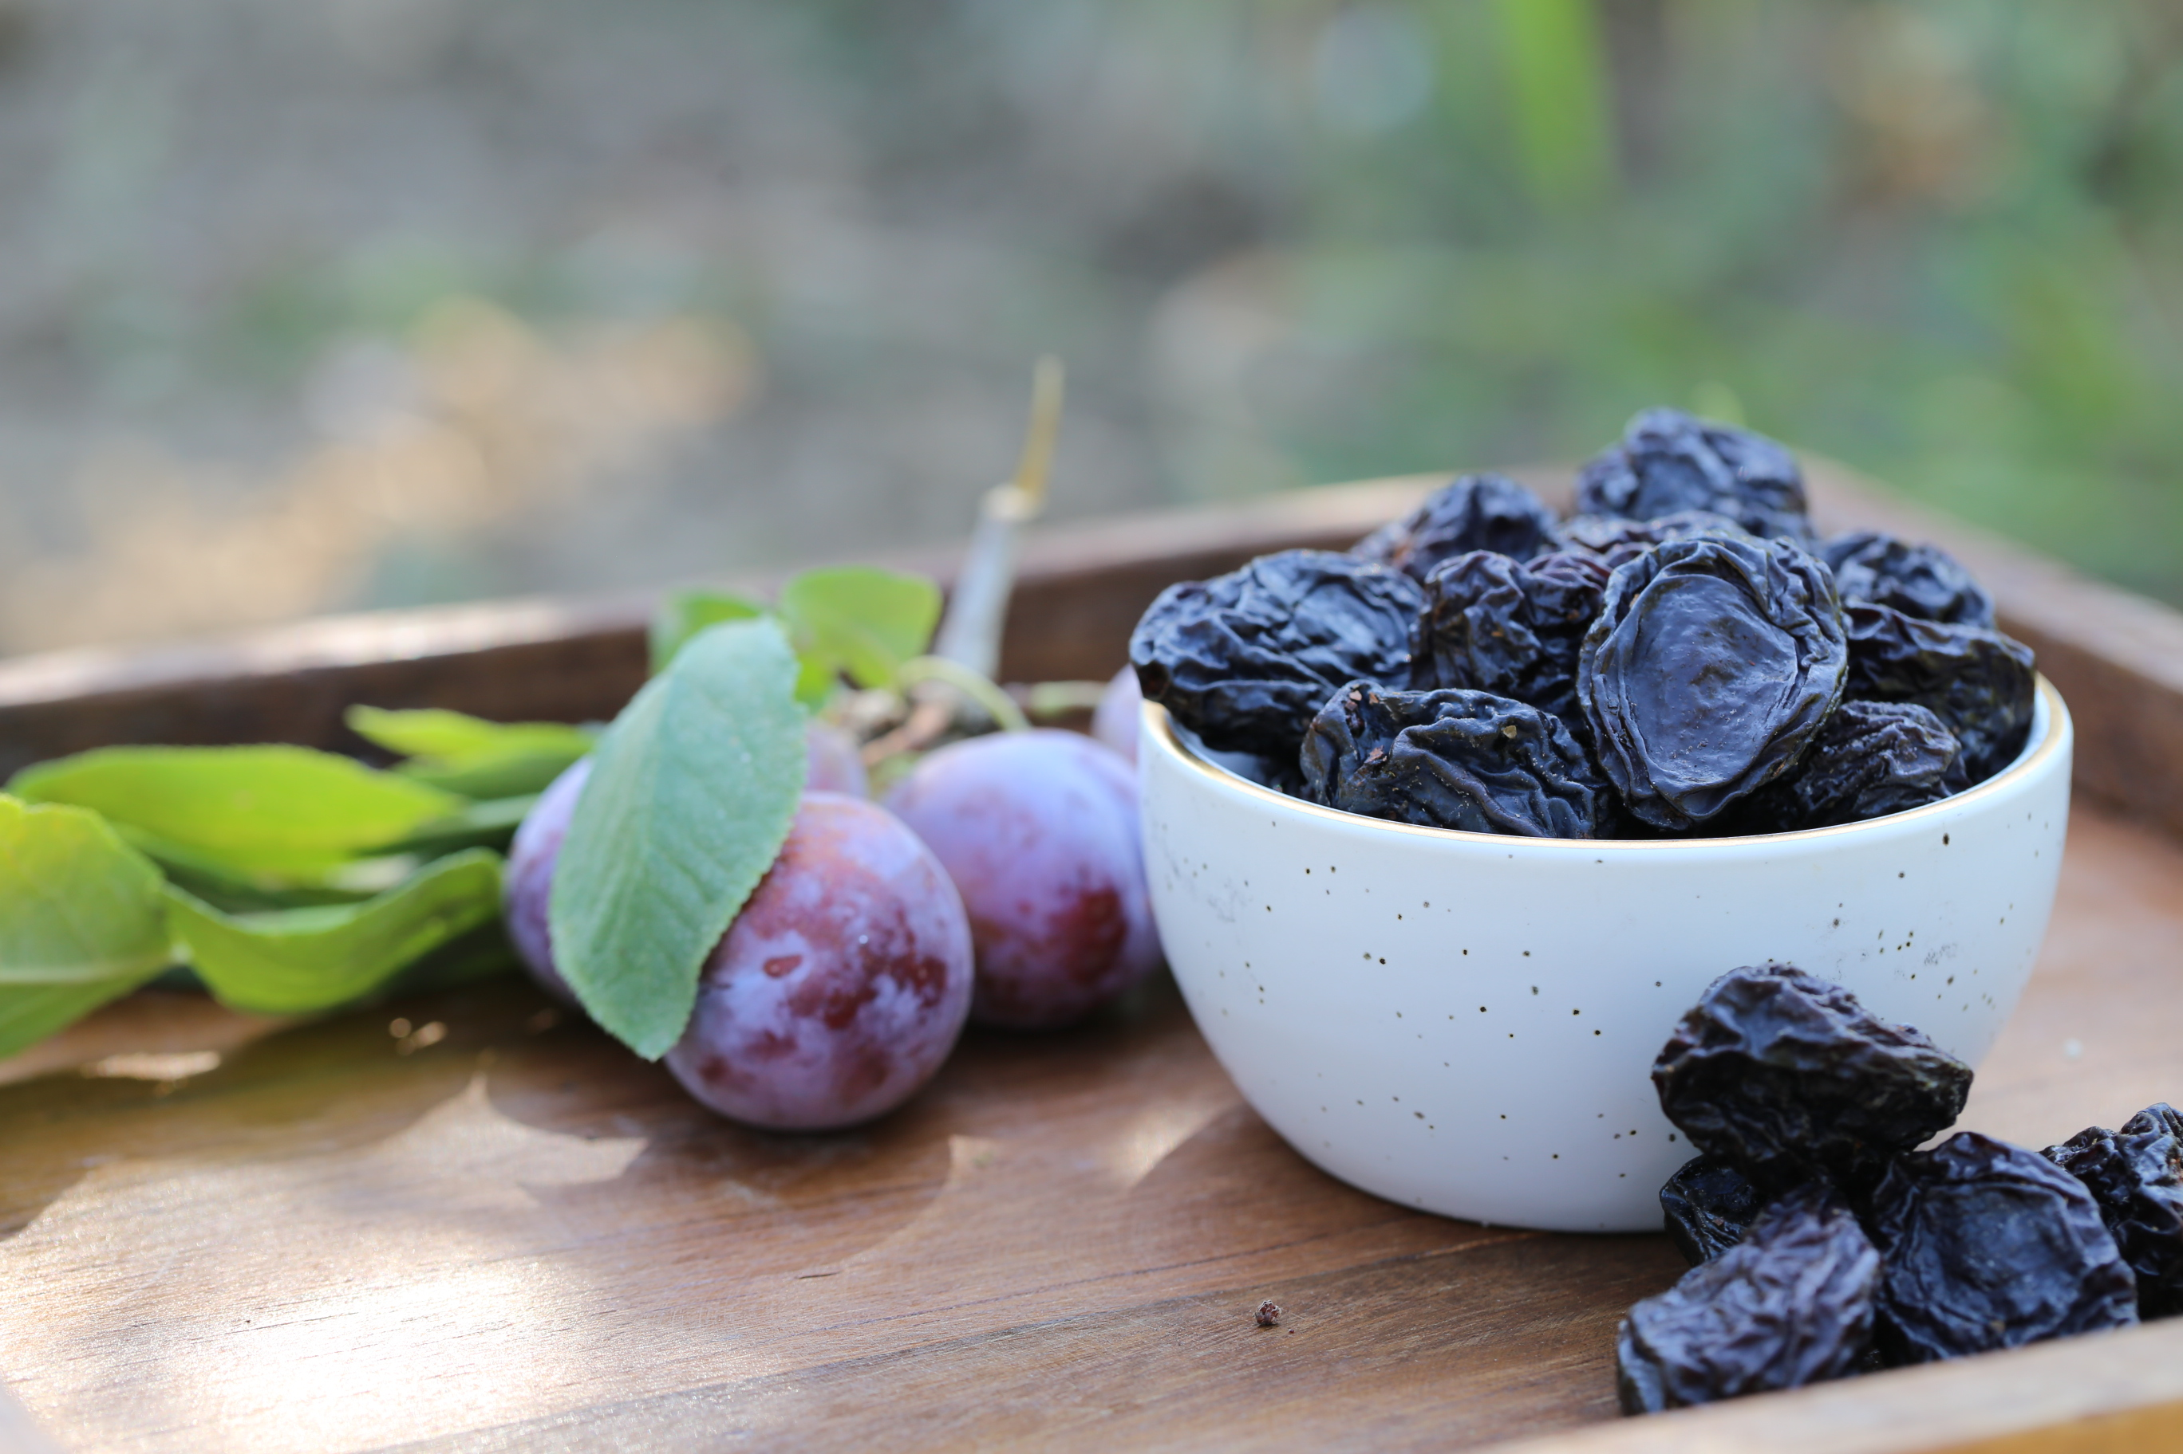

American Culinary Federation
Continuing Education Hours

INTENT:

To award Continuing Education Hours (CEH) it is important to determine that there has been a transfer of knowledge as a result of the Teaching Modules offered. It is our belief that the best way to accomplish this is through application of information regarding California Prunes in the cooking/baking process.

Once you have completed the three Teaching Modules we would ask that you complete the following assignment and survey and submit your response, recipe, and quality photo to the address below. Your materials will be reviewed and if complete, they will be submitted for a CEH award from the American Culinary Federation.

APPLICATION FOR CONTINUING EDUCATION HOURS
California Prunes and the American Culinary Federation

Please complete the following:

YOUR NAME: [ ]
REPRESENTING: [ }
(name of school/program)
SCHOOL ADDRESS: [ ]

[ ]

[ ]

SCHOOL WEBSITE: [ ]

YOUR EMAIL ADDRESS: [ ]

YOUR PHONE #: [ ]

YOUR POSITION (CHECK ONE):
[ ] Faculty Member
[ ] Student
[ ] Staff Member
[ ] Program Alumni
[ ] Program Administrator

Please respond to the following to help us validate your completion of the modules:

I acknowledge that I received and completed a review of the three Teaching Modules on California Prunes.

____________________________________ _______________
(Your Signature) (date)

ASSESSMENT OF PROGRAM:
(Please rate your answers – level of agreement using the following scale)

4 = Strongly agree
3 = Agree
2 = Disagree
1 = Strongly disagree

- I found the modules to be informative and beneficial.
Your level of agreement: [ ]

Comments: [ ]

- The materials were succinct and easy to follow.
Your level of agreement: [ ]

Comments: [ ]

- The materials were thorough enough to provide a new level of enthusiasm for the use of California Prunes.
Your level of agreement: [ ]

Comments: [ ]

- The materials were an appropriate complement to the following courses: (please list all that apply)
Course: [ ]

Course: [ ]

Course: [ ]

Course: [ ]

- The materials were helpful in the development of the recipe attached to this application.
Your level of agreement: [ ]

Comments: [ ]

YOUR DISH:

1. Category: [ ] SAVORY
[ ] SWEET

2. Describe the flavor profile of your dish:

3. What role do California Prunes play in developing the flavor profile of this dish?

4. Where would you see the application of this dish?
[ ] Fine Dining
[ ] Casual Dining
[ ] Cafeteria
[ ] Quick Service
[ ] Banquets and Catering
[ ] Home Application
[ ] Retail Bakery
[ ] Restaurant Dessert Menu
[ ] Other
YOUR RECIPE
______________
NAME OF DISH: [ ]
NUMBER OF PORTIONS: [ ]
PRIMARY PREPARATION METHOD USED:
[] Grilling [] Saute [] Roast
[] Braise [] Poach [] Deep Fry
[] Bake [] Freeze

Portion / Measurement | Ingredients | Procedure

ADDITIONAL COMMENTS:

5) Please include at least two close-up, quality, jpeg color photos of the dish from different angles.

RELEASE:

By signing this document I state clearly that this dish is original (to the best of my knowledge) and that I was the person who developed said recipe. I agree to allow California Prunes to use this recipe and photos as they see fit providing credit is given for the original dish.

__________________________________________ ___________________
(Your Name) (date)

Please submit all materials to:

Amanda Frew
Fleishman Hillard
(representing California Prunes)
amanda.frew@fleishman.com

